UEFA Documentation
External Researchers Request Form

UEFA Documentation:
Request Form for External Researchers

Personal Information

Surname: |  |  | Name:
Date of birth:

University/ Organisation

Name: |  |  | Faculty, department:
Students: | Yes No |  | If no, position:

Contact details

Address: |  |  | Country:
Telephone: |  |  | Fax:
E-mail:

Research

Research title:

Research aims:

Topic(s): | Economics | History | Law
 | Management | Marketing | Political Sciences
 | Sociology | Media & Communication | Other:

Type of research:

Masters, MBA | Doctoral (PHD) | Post doctoral
Consultancy project | Personal research | Other:

Expected outputs (multi-answers possible):

Student Paper | Article | Book
Conference | Other:

Expected date of termination:

Language(s) of the final document:

Name of research director (if relevant):

Name of co-researchers (if relevant):

Request, needs

What type of information are you looking for?

What kind of support do you expect from UEFA?

Contact Details

Applications and any other correspondence relating to the UEFA Documentation should be sent to the following:

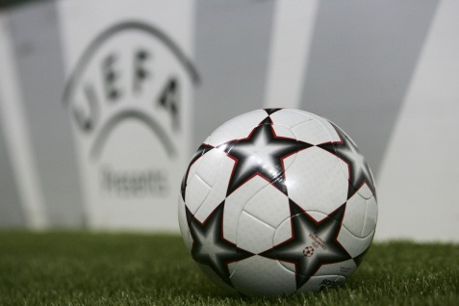
UEFA Universities
UEFA
National Associations Division
Route de Genève 46
CH – 1260 Nyon
Suisse

E-mail: universities@uefa.ch

