Minimum Medical requirements

Pre-tournament information provision: mini-tournaments

## **UEFA pre-tournament information provision form (mini-tournaments)**

## This form is designed to assist clubs/associations in their compliance with chapter 3 of UEFA Medical Regulations – Minimum Medical Requirements for Players, Team Officials, the Referee Team and Match Officers and with UEFA Medical Requirements for mini-tournaments. The form should be completed by the host club/association and must be sent to the UEFA match delegate at least two weeks in advance of the first match of the tournament.

The form aims to confirm the following information to UEFA:

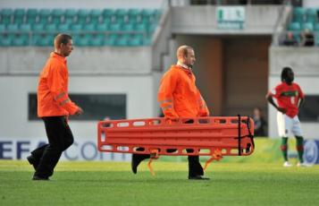

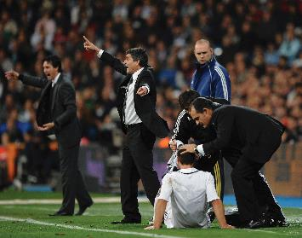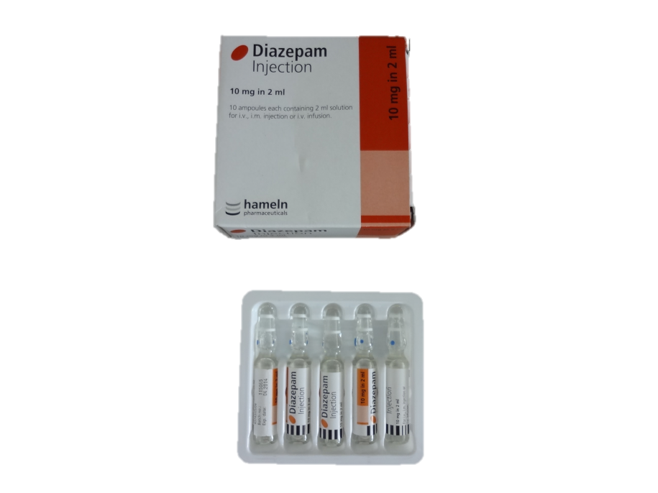

* Whether any legal restrictions are applicable to medical provision at the tournament such as:
  + restrictions on the import or use of medications
  + restrictions on a doctor’s right to practice
* Whether there any important medical requirements to notify to visiting teams such as:
  + Vaccination requirements
  + Sanitary information

That a comprehensive tournament medical service will be in place, including identified medical facilities for imaging and emergencies, medical kit and procedures at tournament venues.

That a nominated English speaking tournament doctor will be appointed to manage medical services before the tournament and will be available 24/7 during the tournament.

|  |  |
| --- | --- |
| **Name of host association** |  |
| **Dates of mini-tournament** |  |

# **Section 1: Mandatory Items**

**1.1 Tournament doctor**

All tournaments must have a doctor appointed who will be responsible for medical services at the tournament. Please provide the following information relating to the appointed Tournament Doctor:

|  |  |  |  |
| --- | --- | --- | --- |
| 1.1a | Tournament Doctor | Name |  |
| Mobile Phone |  |
| Other telephone |  |
| Email |  |

Please circle/delete as applicable. If you do not answer ‘yes’ to these questions, the planning for your tournament is not in accordance with UEFA Minimum Medical Requirements

|  |  |  |
| --- | --- | --- |
| 1.1b | Tournament Doctor is a fluent English speaker? | Yes / No |
| 1.1c | Tournament Doctor will be accommodated at tournament headquarters (or in neighbourhood) for duration of tournament? | Yes / No |
| 1.1d | Tournament Doctor will available 24 hours a day, 7 days a week from the date of the first team’s arrival in the host country until the date of the last team’s departure? | Yes / No |

**1.2 Other medical personnel**

Please provide the names and contact numbers of key medical personnel working at the tournament (e.g. staff responsible for organising medical services at the tournament and pitchside doctors for all matches)

|  |  |  |  |
| --- | --- | --- | --- |
| Name | Tournament function and main responsibilities | Mobile telephone | Email |
|  |  |  |  |
|  |  |  |  |
|  |  |  |  |
|  |  |  |  |
|  |  |  |  |
|  |  |  |  |
|  |  |  |  |
|  |  |  |  |
|  |  |  |  |
|  |  |  |  |
|  |  |  |  |

**1.3 Stadium/hall maps**

Please attach to this document (either electronically or in paper form) a map of all stadiums/halls to be used during the tournament. This must contain at least the following information:

1. location of the ambulance for the sole use of the players, team officials, referee team and match officers
2. emergency exit point from the pitch/ tunnel/ dressing room areas to ambulance
3. location of the medical room

**1.4 Medical plan for training sessions, hotels and team excursions**

Please enclose a medical plan detailing how incidents will be managed during the tournament including:

1. medical communication procedures between tournament medical staff and treatment facilities
2. emergency evacuation plans

Please confirm the following:

|  |  |  |
| --- | --- | --- |
| 1.4 | Teams will receive expedient treatment at all identified reference medical facilities, 24/7 (where applicable) for the duration of the tournament | Yes / No |

Please provide details of all medical facilities that have been identified for use during the tournament. This must include at least 1 x emergency treatment facility for each stadium/hall used in the tournament. Please also include imaging centres, dentists etc.:

|  |  |  |  |  |
| --- | --- | --- | --- | --- |
| Name of treatment facility | Stadium/hall  (if emergency facility) | Address | Medical specialisms  (e.g. imaging, emergency department etc.) | Contact details |
|  |  |  |  |  |
|  |  |  |  |  |
|  |  |  |  |  |
|  |  |  |  |  |
|  |  |  |  |  |

# **Section 2: Recommended Items**

**2.1 Importing medication:**

Please detail below any specific procedures required for visiting doctors to import medication into the host country:

|  |  |
| --- | --- |
| 2.1 |  |

**2.2 Immunisation status:**

Please detail below any specific immunisation advice/requirements for visitors to the host country:

|  |  |
| --- | --- |
| 2.2 |  |

**2.3 Doctor’s right to practice status:**

If a visiting doctor needs to complete any documentation in order to be eligible to treat a member of their team in the host country please provide details below. If not completed it will be assumed that no such requirement exists:

|  |  |
| --- | --- |
| 2.3 |  |

**2.4 Medical equipment**

Please confirm that all medical equipment will be provided as required by UEFA in accordance with Medical Regulations and in particular section III – Minimum Medical Requirements:

|  |  |  |
| --- | --- | --- |
| 2.4a | All UEFA Minimum Medical Requirements will be met in full during the tournament | Yes / No |

Where additional medical equipment will be provided at tournament hotels and training grounds, please detail this below:

|  |  |
| --- | --- |
| 2.4b |  |

**2.5 Payment procedures for medical treatment:**

Please indicate below normal procedures for the payment of medical treatment in the host country. This should include insurance requirements where applicable:

|  |  |
| --- | --- |
| 2.5 |  |

**2.6 Contact staff at identified medical facilities:**

Please indicate below the main contacts at the medical facilities identified for use during the tournament. At least one English speaking contact should be provided for each facility:

|  |  |  |  |
| --- | --- | --- | --- |
| Name of treatment facility | Name of main contact | Main contact telephone number | Email |
|  |  |  |  |
|  |  |  |  |
|  |  |  |  |
|  |  |  |  |
|  |  |  |  |

**2.7 Acknowledgement and agreement:**

By signing the following I confirm that all information provided in this document is accurate and I acknowledge that failure to meet UEFA Minimum Medical Requirements may result in referral of the association to the UEFA Control and Disciplinary Body.

|  |  |  |  |
| --- | --- | --- | --- |
| 2.7 | Name: | Signed: | Date: |